Dr. Matthew C. Saunders
257 East 286th Street—Willowick, Ohio 44095-5031 USA
(580) 461-1617—matthew@martiandances.com

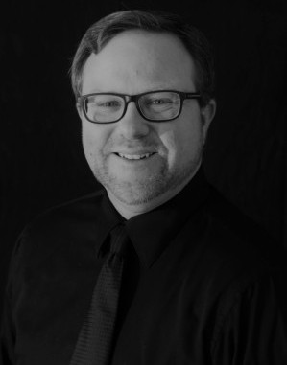
Dr. Matthew C. Saunders (born 1976, Austin, Texas, USA) is a Northeast Ohio composer, conductor, trombonist, husband, and father. He finds inspiration from the vastness of space, the waterways and forests, mountains and prairies of America, the motion of atoms, and the mysteries of existence, and from collaboration with other musicians and his students. After a hard day’s work, he relaxes with his wonderful wife, who is the love of his life and his teammate in the extreme sport of parenting. Dr. Saunders is a lover of solitude and camaraderie, Cincinnati-style chili and Carolina barbecue, road trips, movies, and random facts. His favorite dinosaur is the Parasaurolophus. He gets excited about music that he would never write or perform, and does what he can to share that with the world. Dr. Saunders is Professor of Music at Lakeland Community College, where he directs the Lakeland Civic Orchestra.

